**It’s Yoga Cincinnati**

**Spring/Summer 2025**

**RYT 200**

**Registered Yoga Alliance**

**Yoga Teacher Training Packet**

**Begins March 21-23, 2025**



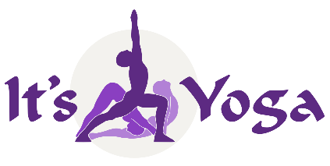

Thank you for inquiring about our Registered Yoga Alliance Teacher Training Program (RYT

200). **It’s Yoga Cincinnati** is the first Yoga Alliance Registered Yoga School (RYS) in Cincinnati. With over 25 years’ experience specializing in training yoga teachers. We are proud of our outstanding reputation for producing top-quality creative teachers who live and love the yoga lifestyle. Our graduates are highly sought after, teaching all levels of yoga at studios and gyms around the world.

Unlike most training programs that are limited to one style of yoga, our program offers training in two distinct but complementary traditional styles as well as an intorductions to Chair Yoga and Yoga Nidara:

* **Ashtanga Vinyasa Yoga** The most challenging style of classical yoga and foundation of

All Vinyasa, Power Yoga and Flow styles

* **Hatha Yoga** Individualized postural alignment as well as the

Traditional meditative style for any yoga level

These styles are presented so that the yoga teacher learns how to teach a challenging class for those who are ready, but also a less demanding class for beginners, senior citizens, or for those who prefer a more relaxed meditative approach.

We also emphasize a well-rounded introduction to all traditional aspects of yoga, including

techniques for meditation and pranayama (breathing exercises) as well as an intensive study of yoga philosophy (Patanjali’s *Yoga Sutras*), yoga theory, functional anatomy, fascia alignment, “Pure Movement Technology,” subtle anatomy, introduction to Ayurveda, English and Sanskrit asana tearms and pronunciation.

A unique aspect of our program is the opportunity for practice teaching. Prospective

teachers gain real practical experience by observing, assisting and teaching during public classes. This allows the prospective yoga teacher to gain experience and confidence in their teaching abilities. The program also offers nine months of free classes at It’s Yoga.

After you completed your RYT 200 training, we also offer an Advanced Training program for those who wish continue their training and earn a RYT 500 Certification, which qualifies you as a RYT 500 Professional Yoga Teacher.

If you are interested in our comprehensive yoga teacher training programs please submit the application form on page 11, including answers to the questions on the 11th page along with your application fee. Feel free to contact me personally at (513) 300-5586 or [itsyogaindu@earthlink.net](mailto:itsyogaindu@earthlink.net) if you have questions or need more details.

Indubala Bhardwaj, ERYT 500, T500, YACEP



**A National Yoga Alliance Registered Yoga School RYS 200/300**

**What’s different about It’s Yoga Cincinnati’s RYT Yoga**

**Teacher Training Program?**

It’s Yoga Cincinnati’s Teacher Training Program is scientifically designed by

experts and specialists who have harnessed the expertise of our Yoga Teacher Trainers in order to provide a full spectrum integrated approach to yoga postures, health, and traditional yoga lifestyle choices.

**Level 1 RYT 200-Hours Certification**

The 200-hour training is a time-tested program designed to enhance the overall health of the yoga practitioners by deepening and refining the layers of their yoga practice. Set yourself apart from other yoga teachers by learning skills that will proactively protect against physical and mental injury using Pure Movment Technology as well as learning to lead a professional, safe and effective yoga class.

**This customized program is an integrative approach** that focuses on the new anatomic apooroach we call “Pure Movement Technology” the study of asanas based on *Function, Tensigrity, Fascia Alignment , Biotensigrity and Integrated Movement.* Emphasis is placed on both physical and psychological benefits and developing a balance between strength, stability and range of joint motion. Personal empowerment lifestyle models are presented allowing trainees to explore various traditional yoga methods that can be used to harmonize the body, mind and spirit.

**Standards are enhanced in preparation for professional level training (RYT 500)** By the introduction of Raja Yoga, Yoga Philosophy, Sanskrit terminology & pronunciation, Yoga Technology and Ayurveda. We use a variety of visual aids based on: skeletal models and the study of common movement patterns that tend to result in repetitive stress injury.

**Students learn to conduct classes in several styles** such as Hatha, Modified Ashtanga and Vinyasa Yoga so that trainees can modify their teaching repertoireaccording to current demands of various yoga studios. Class observations and practiceteaching requirements help trainees develop experience and confidence in their teaching skills before completing the program. Nine months of free classes gives the trainee ample opportunity to improve their practice and observe experienced RYT teachers.

**RYT 200 Program Content:**

**Functional Anatomy** - bones, joint capsule mobility, common asana problems & mechanics

**Pure Movement Technology and Integrated Movement –** includes study of joint movement and the effects of fascia, spinal tensigrity, muscles chains and patterns

**Therapeutics** - - - postural diagnostics, body reading & correcting common posture problems and introduction to yoga as therapy

**Posture Adjustment Techniques** - - - verbal & physical (2 finger) gentle adjustments

**Asana Technique** - - - moving from the center, joint integrity, improving range of movement (ROM), postue benefits, contraindications & aligning the energy pathways (nadis)

**Raja Yoga** - - - meditation techniques, Yoga Sutras & Yoga Philosophy

**Pranayama**- - - ujjayi breathing, 5 prana vayus, 5 Bhuta, subtle anatomy & chakras

**Sanskrit** - - - popular terminology, asana pronunciation

**Theory** - - - tristana, gunas, drishti, importance of bandhas

**Yoga Tradition**- - - history of yoga, lifestyle, introduction to Ayurveda & Ancient Sankhya Yoga Theory

**Teaching Methodology** - - - practice teaching and cueing, class observation & assisting,

**Ethics** - - - psychology of teaching, student teacher relationships & marketing

**9 Months of Free Classes for all trainees**

**It’s Yoga *requires a minimum of 90 hours of yoga class attendance* during training up through 9 months to be eligible for certification**. This way yoga trainees become exposed to a variety of yoga class styles, teaching methods and teachers. If you live at a distance we will help your to work out an alternate method of class attendance.

**Eligibility** is open to any sincere yoga student who has practiced yoga in a studio and thirsts for a deeper understanding of the science and tradition behind asana practice. You must also be at least eighteen years of age. With a few exceptions, we require full attendance during teacher training weekends. Missed time and material must be made up!

**Required Reading during Teacher Training** (books included with tuition)

1. It’s Yoga Cincinnati Teacher Training Workbook & Technique Manual, by Indubala Bhardwaj,

ERYT500, T500, YACEP

2. Functional Anatomy of Yoga, A Guide for Practitioner’s and Teachers by David Keil

3. The Yoga Sutras of Patanjali – an axxessible commentary by Kurt Matthys

**Financial Arrangements & Payment Plans are available(see page #10** Questions? contact Indu Bhardwaj at 513-300-5586, text or email [itsyogaindu@earthlink.net](mailto:itsyogaindu@earthlink.net)

**Training Dates are listed on page #11**

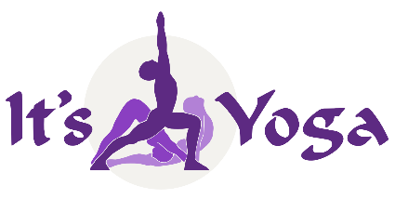

**RYT 200 Yoga Teacher Training Graduation Requirements**

**1. 200 + Training Hours**

● Technique: 105 contact hours + 15 non-contact hours = 120 total hours

● Yoga Philosophy: 30 contact hours + 5 non-contact hours = 35 total hours

● Anatomy: 15 contact hours + 10 non-contact hours = 25 total hours

● Teaching Methodology: 25 contact hours = 25 total hours

● Practicum; 10 contact hours + 11 non-contact hours = 21 total hours

● Electives: 30 non-contact hours = 30 total hours

**Note:** **Contact hours required to be under direct supervision of the Primary ERYT 500 Lead Trainor**

**2. Homework Assignments**

● Reading and Written assignments from the ***Teacher Training Workbook*** & ***Technique Manual***

● Script development

● Asana Flash Cards + Benefits & Sanskrit Pronunciation

● Teacher Training participation & 90 hours yoga class participation

● Reading assignments**: Technique Manuel, Workbook, Functional Anatomy & *Yoga Sutras***

● Observing a minimum of 2 yoga classes between sessions

**3. Examinations** (passed with a score of 70% or above)

● Functional Anatomy Exam

● Yoga Theory & Philosophy Exams

● Yoga Technique Exam

● Practical Examination

***NOTE: 90 hours of open class attendance is required for graduation. Contact Indu at***

***513-300-5586 if you live out out of town***

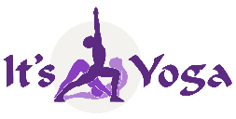

**Yoga Teacher Trainers**

***No yoga teacher training program attains excellence without a***

***dedicated and highly experienced director & staff***

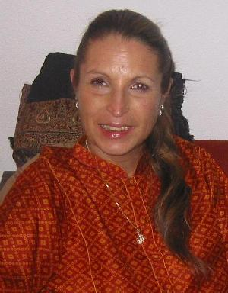

**Indubala Bhardwaj, MT, ERYT 500, T500, YACEP**

**Experienced Professional Yoga Teacher & Lead Trainer**

**RYT 200/300 Teacher Training Program Director**

Indu’s has been teaching yoga in Cincinnati since 1980. She began her yoga practice in 1968, after meeting Swami Satchidananda.

After a career in classical ballet, she studied Medical Massage Therapy at the Canadian College of Massage and Hydrotherapy and was licensed in 1974. In 1976 Indu met her mentor, Pundit Yogi Raj Sharma Shastri and studied Yoga Philosophy, Sanskrit, and Brahm Vidya Shastra for 22 years. In 1985 was initiated into the Mahanubhava Marg by Late Rajdhar Baba of the Samvatsar Ashram in Maharashtra, India. From 1980 – 1991, Indu was one of the founding fathers of Cincinnati’s first Hindu Temple in Cincinnati. She served as a Board Member, holding several offices as well as Vice President and Editor of Aradhana.

In 1998 Indu co-founded the first yoga studio in the Tri-State Area (Cincinnati Yoga School). Then, in 2000 co-founded It’s Yoga Cincinnati, RYS 200 & 300 as the first Yoga Alliance Registered Yoga School to train yoga teachers.

Though Indu teaches yoga classes and workshops, she has specialized in training yoga teachers for the past 23 years. On October 2016, she was honored by the Cincinnati Yoga Teachers Association with a Life-Time Achievement Award presented by The Mayor of Cincinnati and Cincinnati’s sister city, Mysore, India.

Indu is an expert in yoga myofascia anatomy, inspired from her background in movement, and massage along with studies with Dough Keller in “Yoga as Therapy” and “Fascia Alignment” with Thomas Meyers.

Being an avid student of intelligent pure movement and integrated anatomy, Indu helps yoga students learn how to approach postures with ease and awareness while at the same time incorporating breath, bandhas and drishti. She believes in living a yoga lifestyle both on and off the mat as best be defined by The Bhagavad Gita as ***“skillfulness in action”***

**Certifications**

RYT 500 Hatha Yoga, Pranayama & Meditation Integral Yoga

RYT 200 Ashtanga Yoga & Rocket Yoga It’s Yoga San Francisco – Larry Schultz

RYT 300 Swastha Yoga & Ayurveda Ganesh Mohan

RYT 148 Yoga as Therapy Doug Keller

RYT 150 Raja Yoga Integral Yoga

RYT 80 Yin Yoga Paul Grilley

RYT 75 Cardiac Yoga Integral Yoga

**Addidional Training & Workshops**

Certified M.S. Yoga Instructor National Multiple Sclerosis Society

Certified in Pilates & Allegro Reformer Twenty First Century Pilates Training

Certified Fitness & Aerobics Instructor Exercise Science Allianc

Pattabhi Jois Ashtanga Vinyas

**Indu Cont. next page**

Richard Freeman Ashtanga Vinyasa

David Williams Ashtanga Vinyasa

Kino Mac Gregor Ashtanga Vinyasa

David Kiel Mysore Style Ashtanga

John Coon Vinyasa Krama

Srivatsa Ramaswami Vinyasa Krama

Thomas Meyers Fascia Anatomy, Movement

Vyaas Houston, **American Sanskrit Institute** Sanskrit 1-3 levels

Julie Cortier, **Body Mind Balance** Gyrotonics & Power Pilates (10 years)

**Kurt Matthys, BA, ERYT 500, T 500**

**Experienced Professional Yoga Teacher & Trainer**

Kurt has studied, practiced, meditated and lived the “*yoga lifestyle”* for the past 22 years. As a true yogi who lives a life of inspiration both on and off the mat Kurt has trained in many styles of yoga: Ashtanga Vinyasa, Kripalu, Integral Yoga, Hatha, and Vinyasa Krama. His primary focus is Ashtanga Vinyasa. He has mastered the 1st & 2nd Ashtanga Series and continues to work on the 3rd .

For years Kurt has been an enthusiastic student and teacher of Yoga philosophy. He first started studying Indian yoga texts privately with Indu Bhardwaj and studies the Yoga Sutras in both Sanskrit and English. Kurt is an enthusiastic lecturer and teacher of yoga asanas and loves introducing yoga teacher trainees to Sanskrit, yoga philosophy. In 2023 Kurt wrote and published *“The Yoga Sutras of Patanjali” An aAccessible Commentary.*

Kurt’s personal teaching style encourages students to *“Focus on the present and be open to change.”* He believes in having fun while at the same time, he teaches his students to flexible enough to accept new challenges. Kurt also emphasizes how important it is for students to develop their own daily yoga practice.

Formally, Kurt was a Computer Systems Architect with Fifth Third Bank until his retirement in 2020, in his spare time he also enjoys woodworking and Kirtan (singing sacred Sanskrit songs). In January, 2016, Kurt was featured as “The Yogi” in Cincinnati Magazine’s article “Secrets of the Super Fit.” In 2022, Kurt authored  **The Yoga Sutras of Patanjali,** an Accessible Commentary. A clear cut English literal translation of Patanjali that the American yoga community easily can understand.

**Certifications**

RYT 500 Ashtanga Vinyasa, Hatha & Pranayama It’s Yoga Cincinnati

RYT 40 Yin Yoga Paul Grilley

RYT 60 Introduction to Sanskrit Indubala Bhardwaj

**Additional** **Training& Workshops**

Vicky Sorenson Ashtanga Vinyasa

David Swenson Ashtanga Vinyasa

David Williams Ashtanga Vinyasa

Larry Schultz Ashtanga Vinyasa & Rocket Yoga

Doug Swenson Vinyasa/ Soft Form

Srivatsa Ramaswami Vinyasa Krama

Pundit Rajmani Tigunait Tantra - **Himalayan Academy**

David Frawley Ayurveda & Yoga

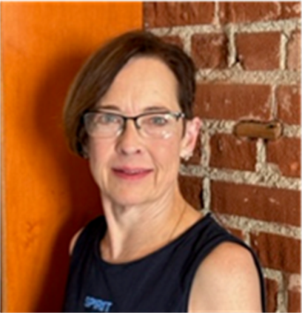**Letty Reifel Hater, BS, MEd, RYT 500**

**Experienced Professional Yoga Teacher & Trainer**

Letty is a Registered Advanced Level Yoga Teacher (RYT 500) as well as a valued teacher of several classes at It’s Yoga Cincinnati. Letty is trained in Hatha, Vinyasa, Ashtanga, Yin, and Chair Yoga. A lifelong learner, she deepened her yoga knowledge by attending workshops with Kino MacGregor in Jivamukti and in the traditional Ashtanga Primary Series.

In her earlier life, Letty was dedicated to the martial art of Tae Kwon Do (TKD). She attained the rank of 4th Degree Black Belt (Kukkiwon Certification), becoming an advanced TKD instructor and a Pan American International Referee of the sport. In 1988 she was invited to become a member of the Olympic Woman’s TKD Team Demo in Seoul, Korea. At that time, she was nominated as the AAU Athlete of the Year as a result of being a champion of numerous national, state and local competitions in Kata (detailed choreographed patterns of martial arts movements practiced alone)and Kumite (training against an adversary).

Letty graduated from Xavier University with BS and MEd degrees, while raising a family.

She served the city of Cincinnati for many years as the first female drafts“man” in the Engineering Department. Later she became the Operations Manager of Cincinnati’s parking facilities.

Letty’s yoga journey was motivated by her passionate interest in keeping active and finding inner balance. She practices yoga to deepen her connection to herself. Accordingly, her life inspiration comes from a verse from the *Srimad Bhagavad Gita*: “Yoga is the journey of the self, to the self, through the self.” Letty invites you to travel along with her as you pursue your own yoga journey at It’s Yoga.

**Certifications**

RYT 500 Ashtanga Vinyasa, Hatha & Pranayama It’s Yoga Cincinnati

RYT 30 Yin Yoga Matt Eshelman

**Education, Additional Training & Workshops**

BS Xavier University

MEd Xavier University

Tae Kwon Do 4th Degree Black Belt Kukkiwon Certification

Kino MacGregor Jivamukti

Kino MacGregor Ashtanga Primary Series

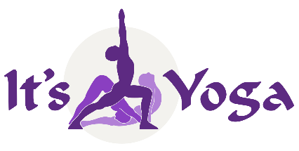

**200-Hour Weekend Yoga Teacher Training**

**Payment Plans – Spring/Summer 2025**

**Option #1:**

***Pre-payment Special to be paid before March 9th***

Paid in-full upon registration $2,700 **(early $100 discount, no registration fee)**

**Option #2:**

**$500 registration fee (prior to March 21st )**

$2,300 balance Due on or before 1st Session March 21st

Total payment $2,800

**Option #3:**

**$500 registration fee (prior to March 21st)**

$470 5-Session payment plan (Due: 2nd through 6th Sessions)

Total payment: $2,850

**Option #4:**

**$500 registration (due by to first session, March 21st)**

$320 8-Session payment plan (Due: 2nd Session through 9th Session)

Total payment: $3,060

***Free 9 monthTT Class Pass begins upon receipt of $500 Registration Fee***

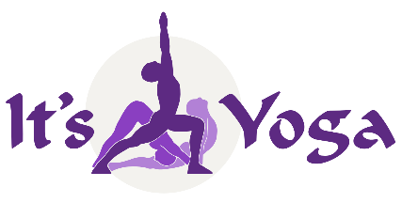

**It’s Yoga Cincinnati, RYS 200 & 300**

**RYT-200 RYT Yoga Teacher Training Application**

Name __________________________________________________________ Date_______________________

Address _____________________________________________________________ Apt _________________

City __________________________________ State _________ Zip ______________________

Phone Numbers: Cell _______________________ Date of Birth: ________________________

Email ________________________________________

Referred By___________________________________

**RYT 200 hour 2025 Dates; Nine Weekend Sessions over Six Months**

**Workshop Session #1 – March 21 – 23**

**Session #2 – Apr. 5 – 6, Session #3 – Apr. 26 – 27, Session #4 May. 17 – 18, Session #5 May 31 – June. 1**

**Session #6 – June 21– 22, Session #7 July 12 – 13, Session #8 July 26 – 27, Session #9 Aug. 9 – 10**

**Sessions #1 Workshop Schedule – Friday – Sunday 8:30 AM – 4 PM**

**Sessions #2 – #9 Schedules are held on Sat. & Sun. 7:30 AM – 6 PM**

* Deposit of $500 must accompany application to reserve your spot
* A $75 non-refundable processing fee is included with your deposit
* A full refund (minus $75 processing free) will be returned if withdrawal occurs before start date
* There are no refunds for previously attended sessions
* Training Materials must be returned upon withdrawal

I understand and accept these terms and agreements.

________________________________________________ _____________________________

**(***Signature***) (***Date*

**Application Form** continues on page 12

**Please answer the following questions along with your application form:**

How long have you studied yoga and what styles have you practiced?

What teachers have influenced you the most?

If you teach, how long have you been teaching?

Do you practice meditation and pranayama? Explain.

Have you studied any yogic texts? Which ones?

Why do you wish to train with It’s Yoga Cincinnati?

What do you hope to gain from this training?

How did you find out about this training?

List prescription medications or special diet that you may be using during training.

List all physical limitations & injuries, including pre-existing condition